Leigh Sinton, A4103 Opposite School Car Park 27/3/22 - 2/4/22 Both Directions – Average Speeds

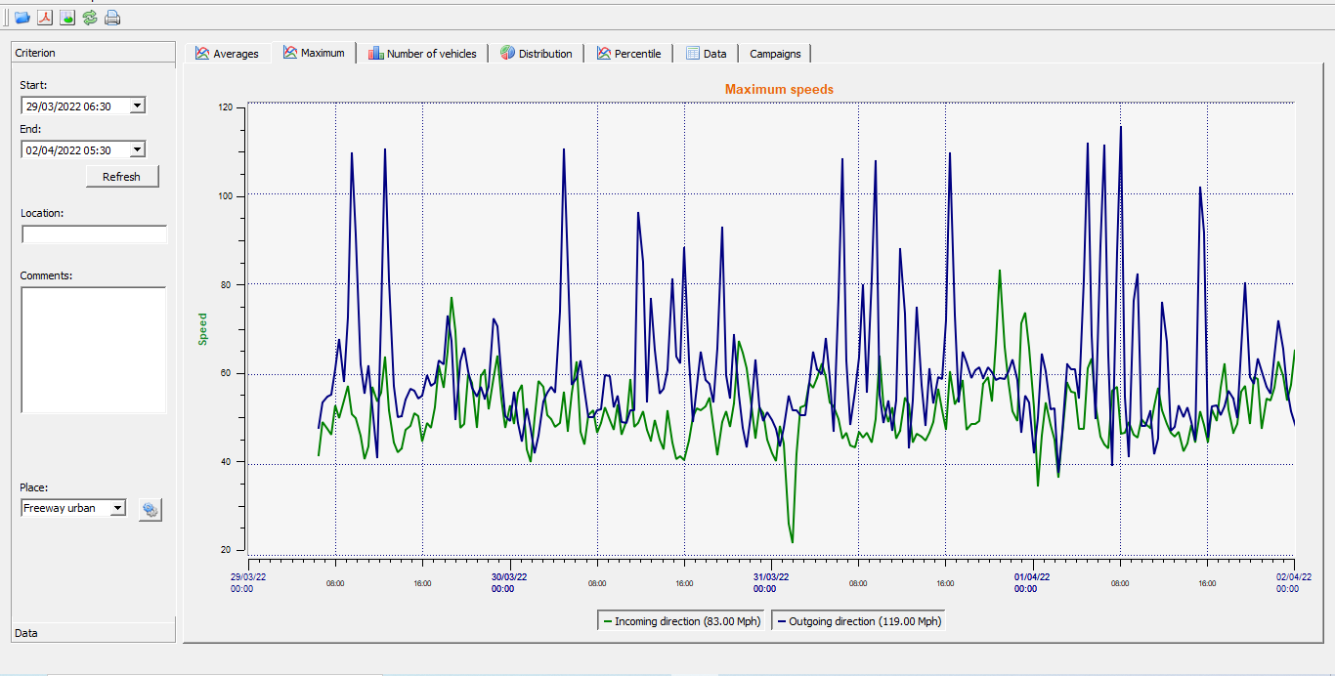

Leigh Sinton, A4103 Opposite School Car Park 27/3/22 – 2/4/22 Both Directions – Speed Distribution

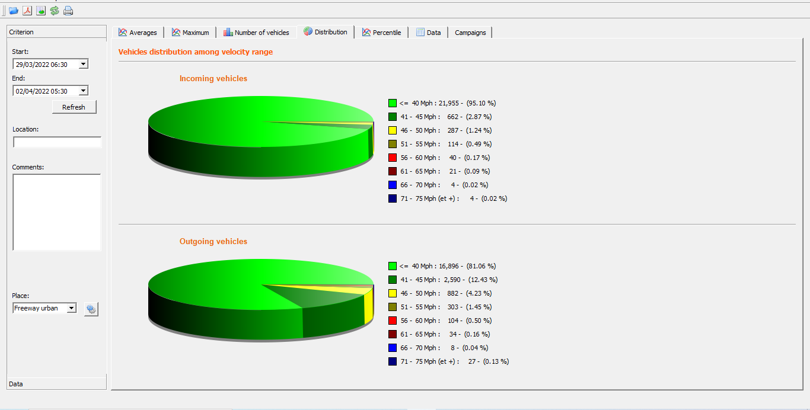

Leigh Sinton, A4103 Opposite School Car Park 27/3/22 – 2/4/22 Both Directions – Percentile Speeds

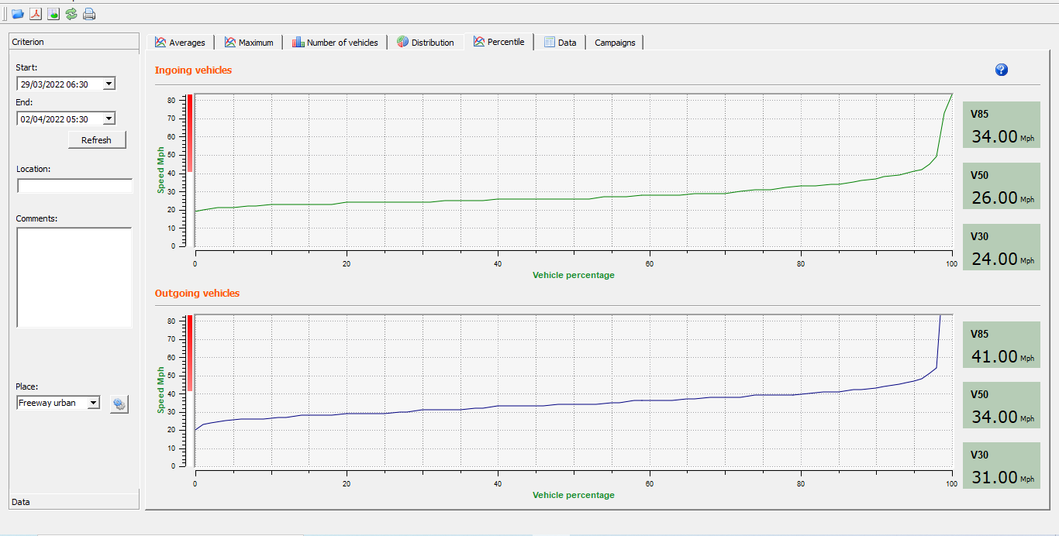

Leigh Sinton, A4103 Opposite School Car Park 3/4/22 – 9/4/22 Both Directions – Speed Distribution

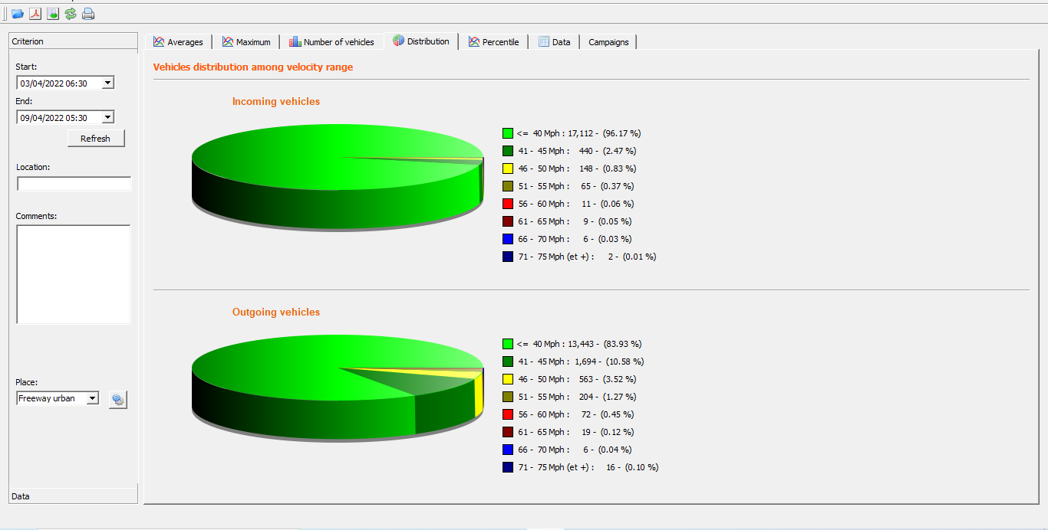

Leigh Sinton, A4103 Opposite School Car Park 3/4/22 – 9/4/22 Both Directions – Percentile Speeds

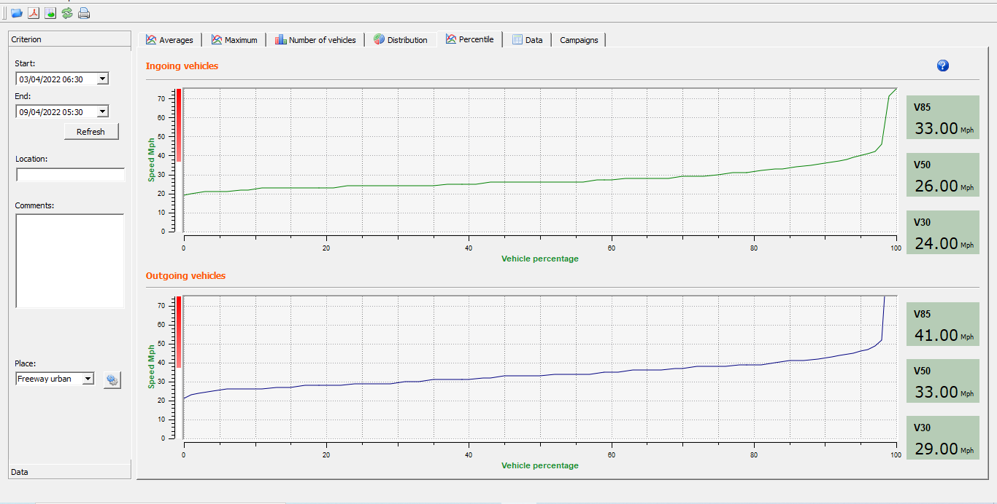

Leigh Sinton, A4103 Opposite School Car Park 10/4/22 – 16/4/22 Both Directions – Speed Distribution

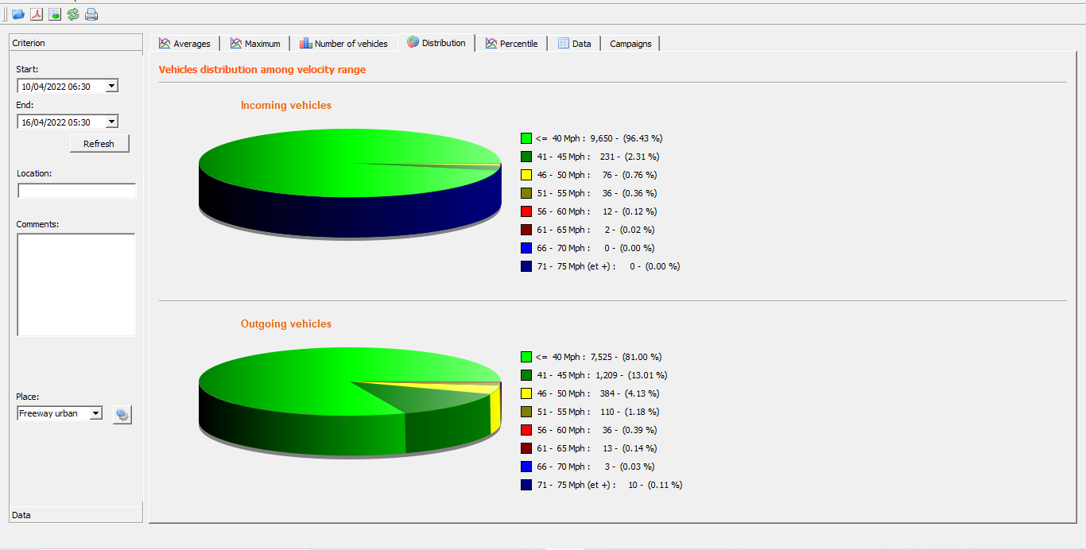

Leigh Sinton, A4103 Opposite School Car Park 10/4/22 – 16/4/22 Both Directions – Percentile Speeds



